NATIONAL MATHEMATICS DAY CELEBRATIONS:
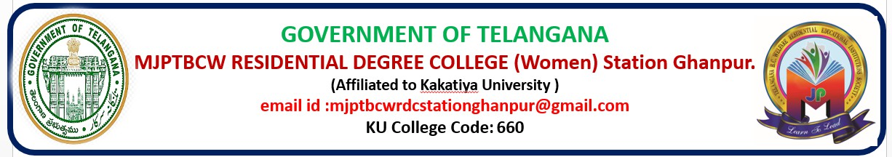
DEPARTMENT OF MATHEMATICS
NATIONAL MATHEMATICS DAY

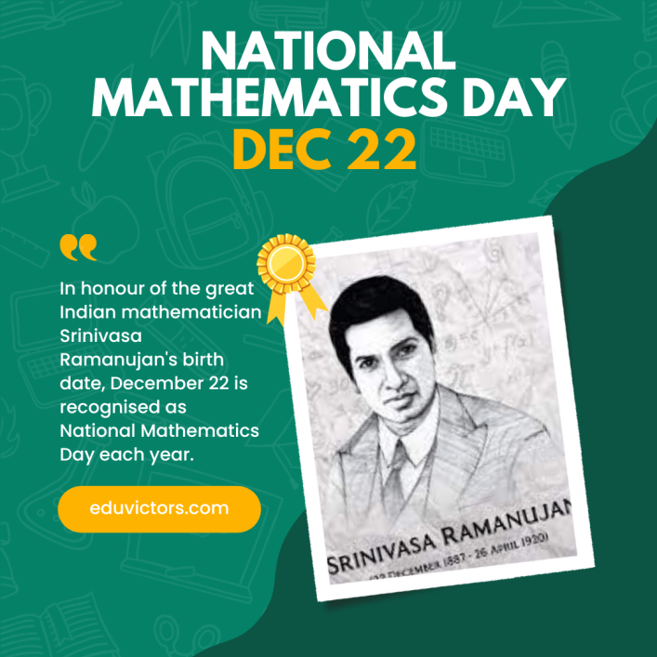

FOR THE ACADEMIC YEAR 2025-26.

CIRCULAR
Date: 22/ 12 / 2025

Subject :Celebration of National Mathematics Day – 22 December 2025
This is to inform all students, teaching staff, and concerned members that National Mathematics Day will be celebrated on Monday, 22 December 2025, in accordance with the academic year 2025–2026.
National Mathematics Day is observed every year to commemorate the birth anniversary of Srinivasa Ramanujan, one of India’s greatest mathematicians. The objective of this celebration is to create awareness about the importance of mathematics in daily life and to encourage logical thinking, problem-solving skills, and mathematical creativity among students.

Details of the Celebration:
- Date: 22 December 2025
- Day: Monday
- Occasion: National Mathematics Day
- Participants: Students and faculty members
Various activities such as mathematical quizzes, competitions, poster presentations, puzzles, and awareness sessions will be organized as part of the celebration.
All students are encouraged to participate actively and make the programme a success. Concerned teachers and coordinators are requested to guide and support students for the smooth conduct of the event.
This circular is issued for information and necessary action.

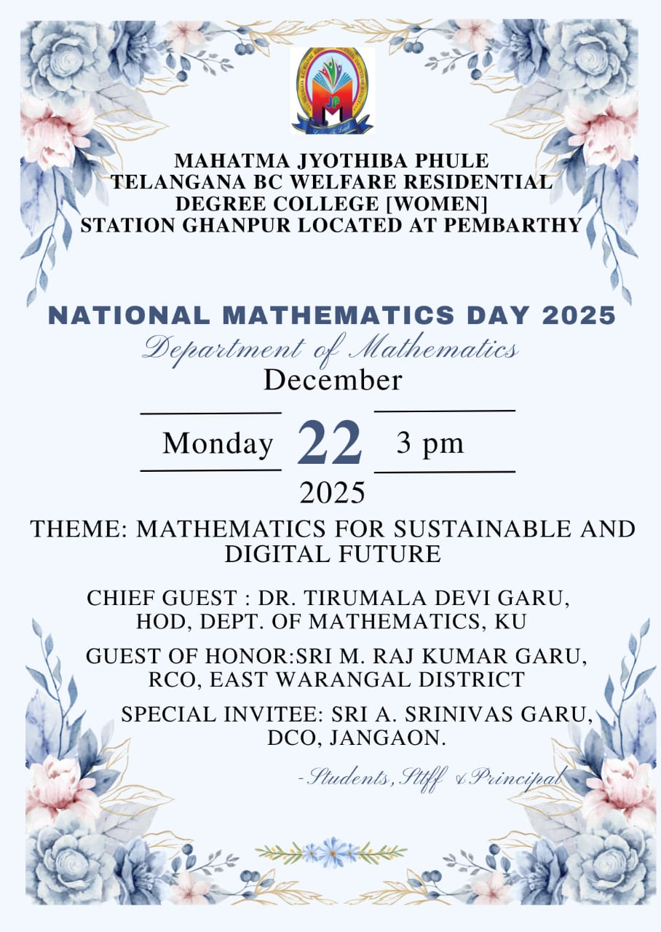
CELEBRATION OF NATIONAL MATHEMATICS DAY
Date: 22/12/2025.
This is to inform all students, teaching staff, and non-teaching staff that National Mathematics Day will be celebrated in our institution on (date), in honor of the birth anniversary of the renowned Indian mathematician Sri Srinivasa Ramanujan.
The objective of celebrating Mathematics Day is to create awareness about the importance of mathematics in daily life and to encourage analytical and logical thinking among students. On this occasion, the Department of Mathematics is organizing various academic and co-curricular activities such as:
- Rangoli competation
- Mathematics quiz
- Treasure hunt
- Paper presentation
Students who are interested in participating in the above activities are requested to give their names to their respective class teachers or the Mathematics Department .Prizes will be awarded to the winners in the above activities ..
All students are expected to participate actively and cooperate to make the programme a grand success.
Date: 22/12/2025.
Time: 8:30 to 9:30 – Rangoli (1 candidate)
10:00 to 11:30 – Quiz ( 3 candidates for a team )
11:30 to 12:30 – Treasure Hunt ( 2 candidates for a team )
2:30 to 3:00 – Inauguration
3:00 to 4:00 – Paper presentation ( 2 candidates for a team )
4:00 to 4:30 – Prize Distribution
Venue: MJPTBCWRDC [W] STATION GHANPUR @ PEMBARTHY
For further information, please contact the Mathematics Department.
Name of the Teacher / Coordinator: H.B INDU
Designation: DL in MATHEMATICS
Department of Mathematics
EVENTS CONDUCTED ON NATIONAL MATHEMATICS DAY

RANGOLI COMPETITION:
- A Rangoli competition was organized with a mathematics theme.
- Students created beautiful designs using numbers, shapes, and mathematical patterns.
- The activity encouraged creativity along with an appreciation for mathematics.
- The best Rangoli designs were awarded prizes and appreciated by the judges.
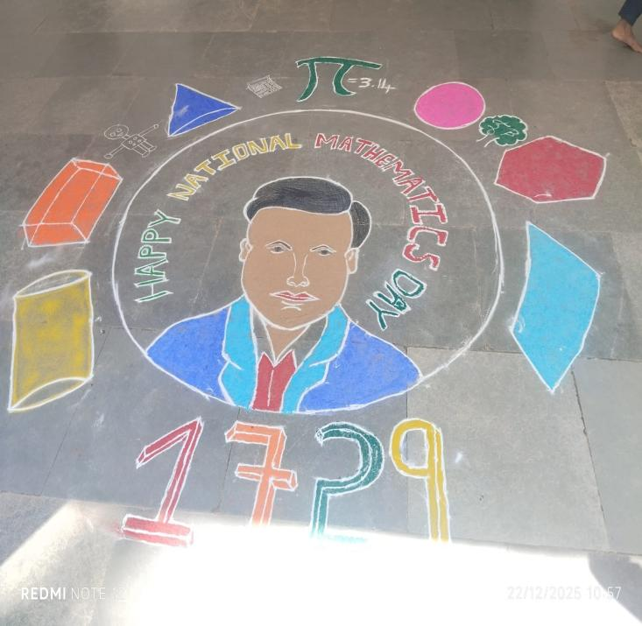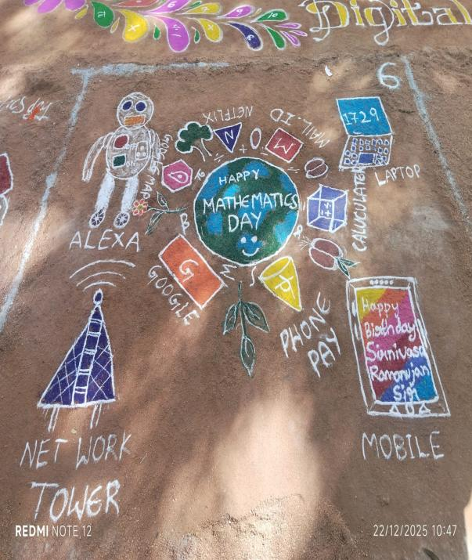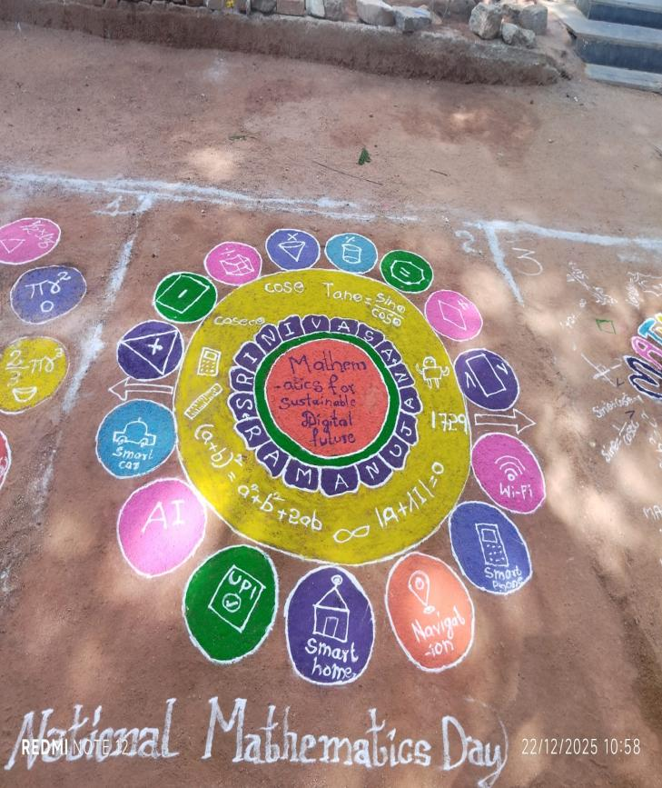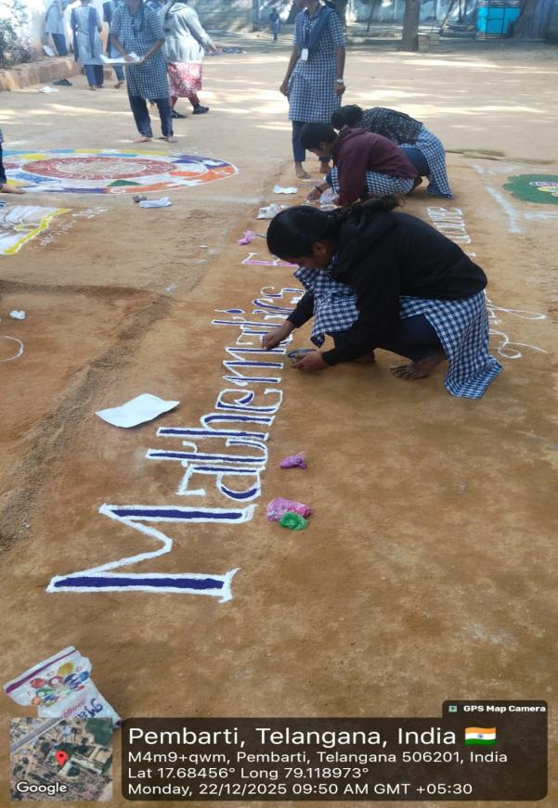

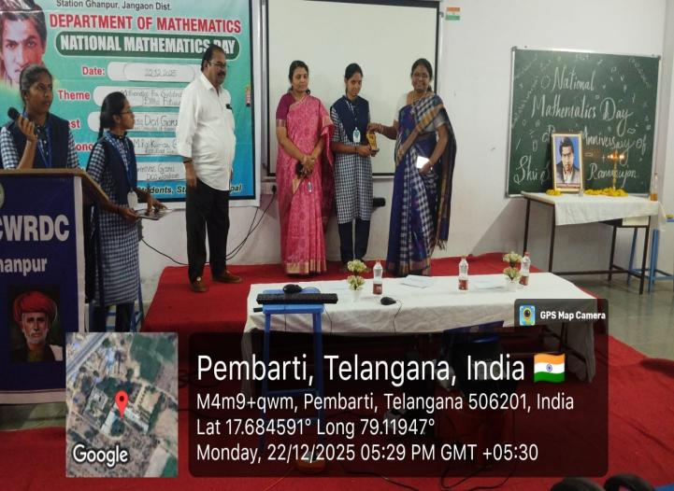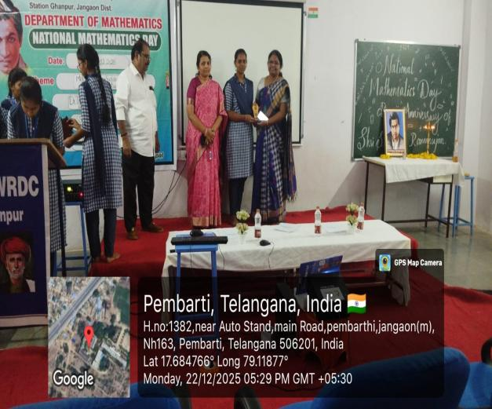

WINNER IN RANGOLI COMPETITION : E. RAMANI (BZC II)
RUNNER IN RANGOLI COMPETITION : A. LAVANYA (MPCS III)

QUIZ COMPETITION :
- The quiz competition was conducted to test students’ mathematical knowledge.
- Participants answered questions related to formulas, logic, and famous mathematicians.
- The quiz was conducted in multiple rounds to increase interest.
- Winners were selected based on accuracy and speed.
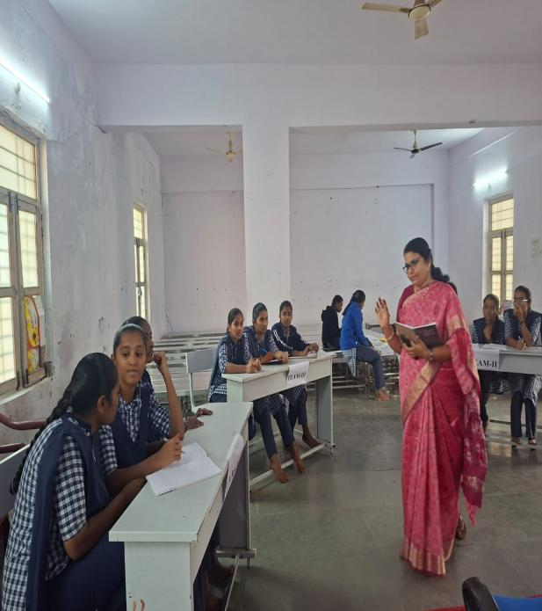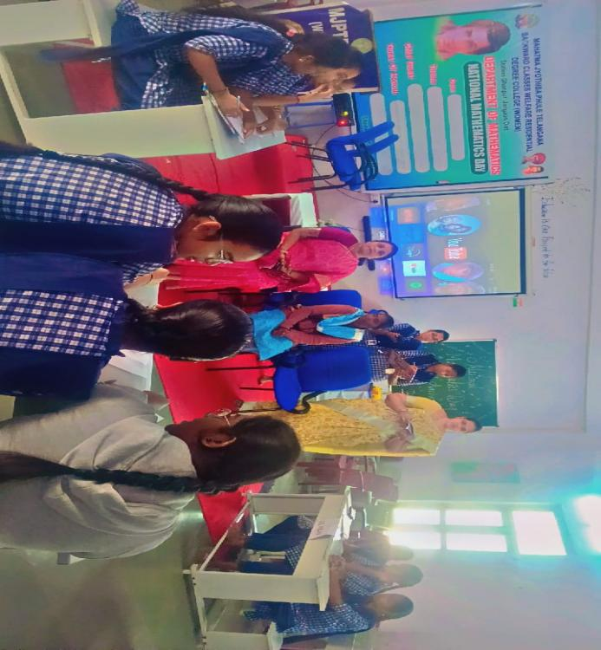
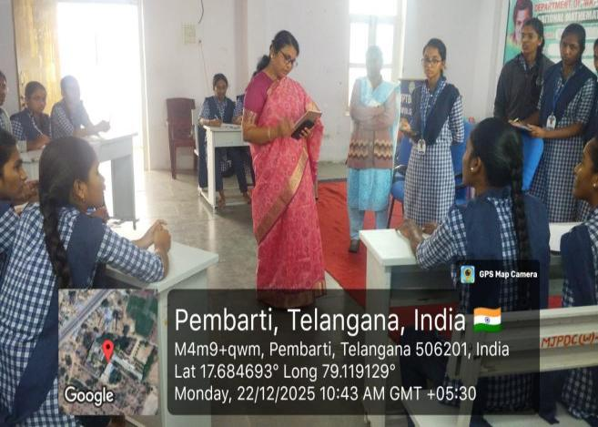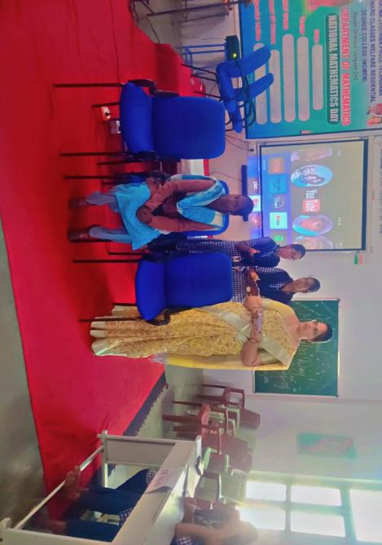
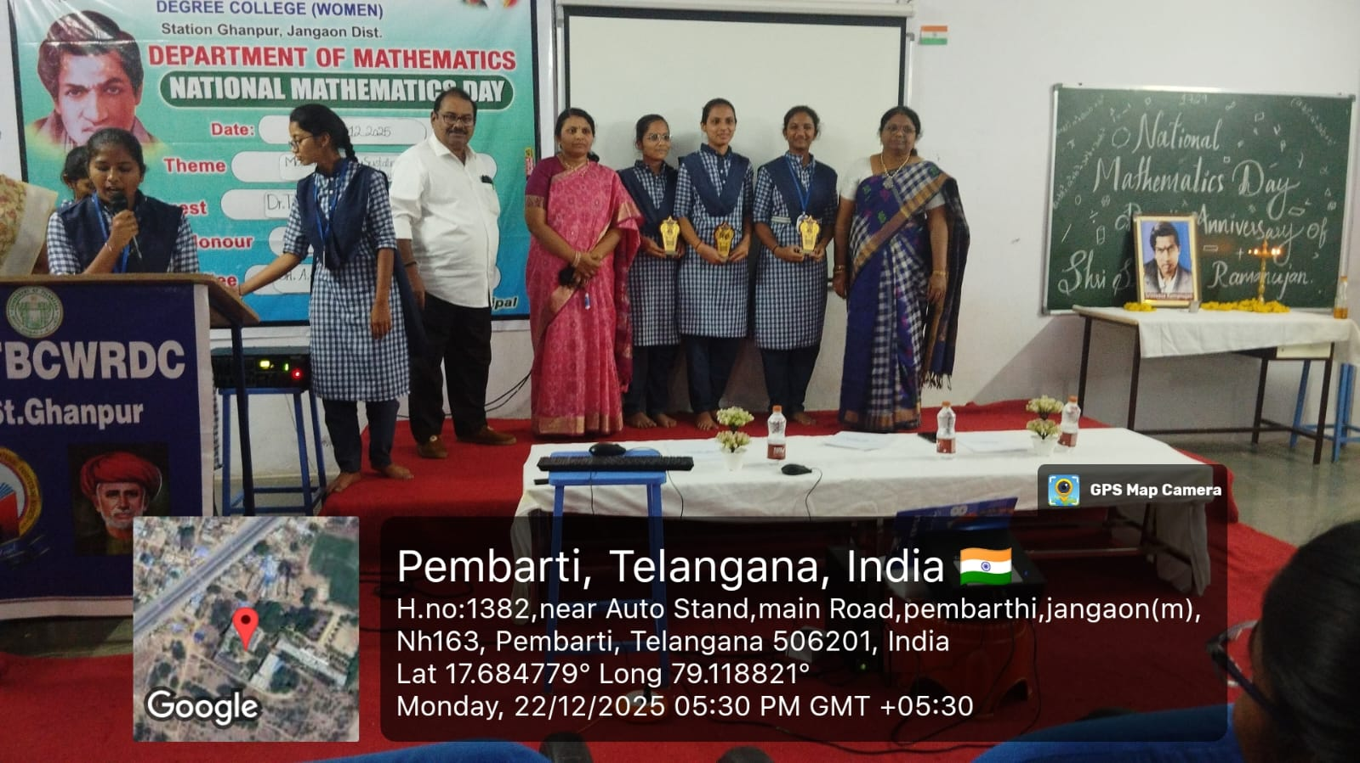

WINNERS OF QUIZ COMPETITON : 1. G.JOSHNA (MPCS III)
- A. PAVANI (MSCS II)
3 . MD SAMREEN BEGUM (MPCS I)
TREASURE HUNT :
- The treasure hunt was organized with mathematical clues and problem-solving tasks.
- Students worked in teams to solve each clue step by step.
- Logical thinking and teamwork were tested throughout the activity.
- The team that completed all levels first was declared the winner.
- The treasure hunt was organized with mathematical clues and problem-solving tasks.
- Students worked in teams to solve each clue step by step.
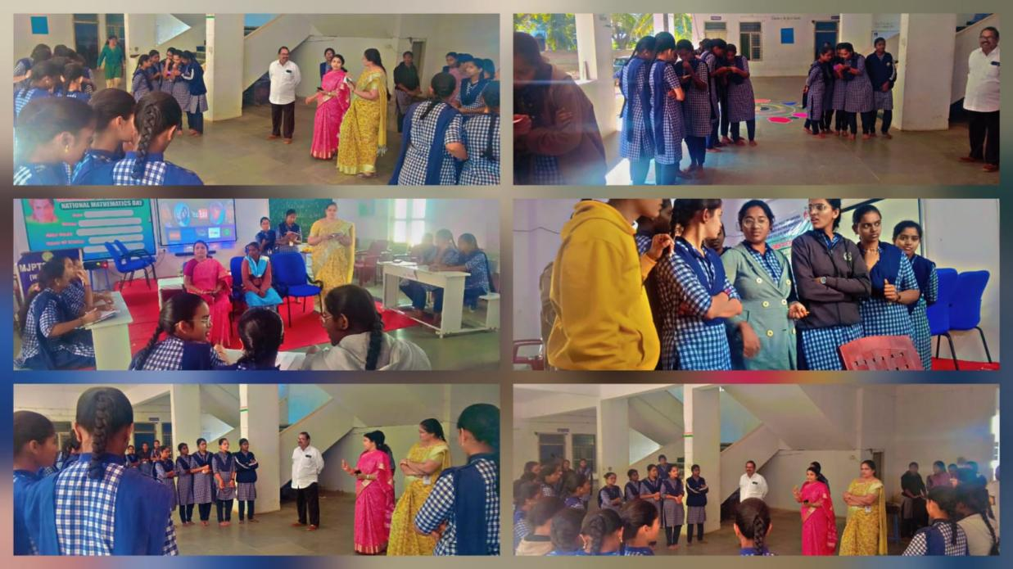

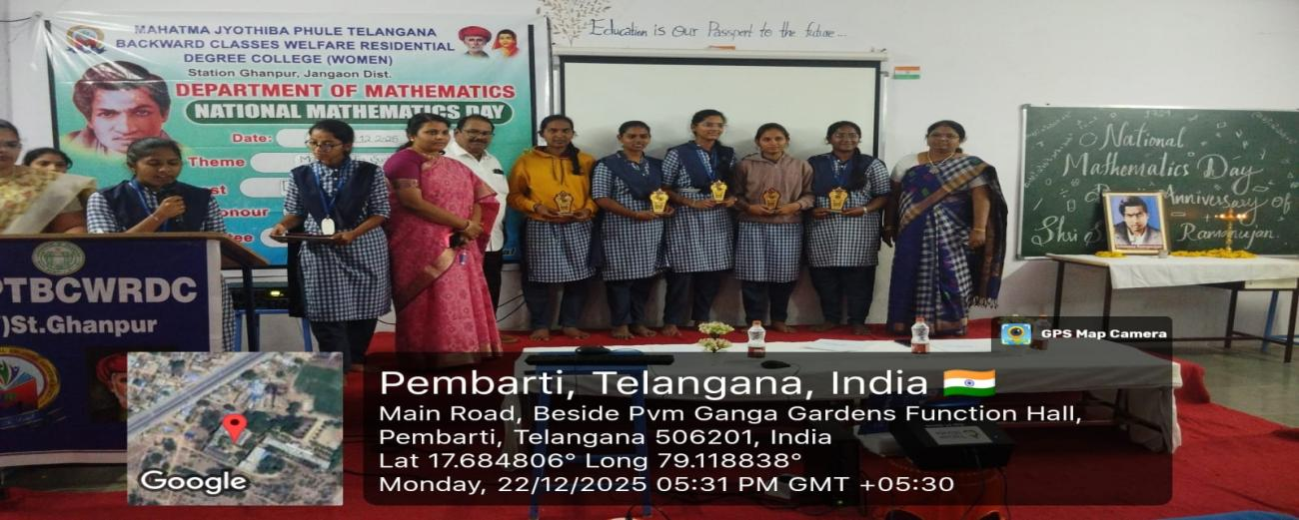
TREASURE HUNT WINNERS : 1. M.SPANDHANA
2.N.BHAVYA
3.A.LAVANYA
4.V.SHIREESHA
5.R.VAISHNAVI
INAUGURATION OF NATIONAL MATHEMATICS DAY
The inauguration of National Mathematics Day was held to celebrate the birth anniversary of the great mathematician Srinivasa Ramanujan. The program began with a prayer and the lighting of the lamp. The importance of mathematics in education and daily life was highlighted by the speakers. Students were motivated to develop logical thinking and problem-solving skills. The inauguration marked the beginning of various mathematical activities and inspired everyone to appreciate the value of mathematics.
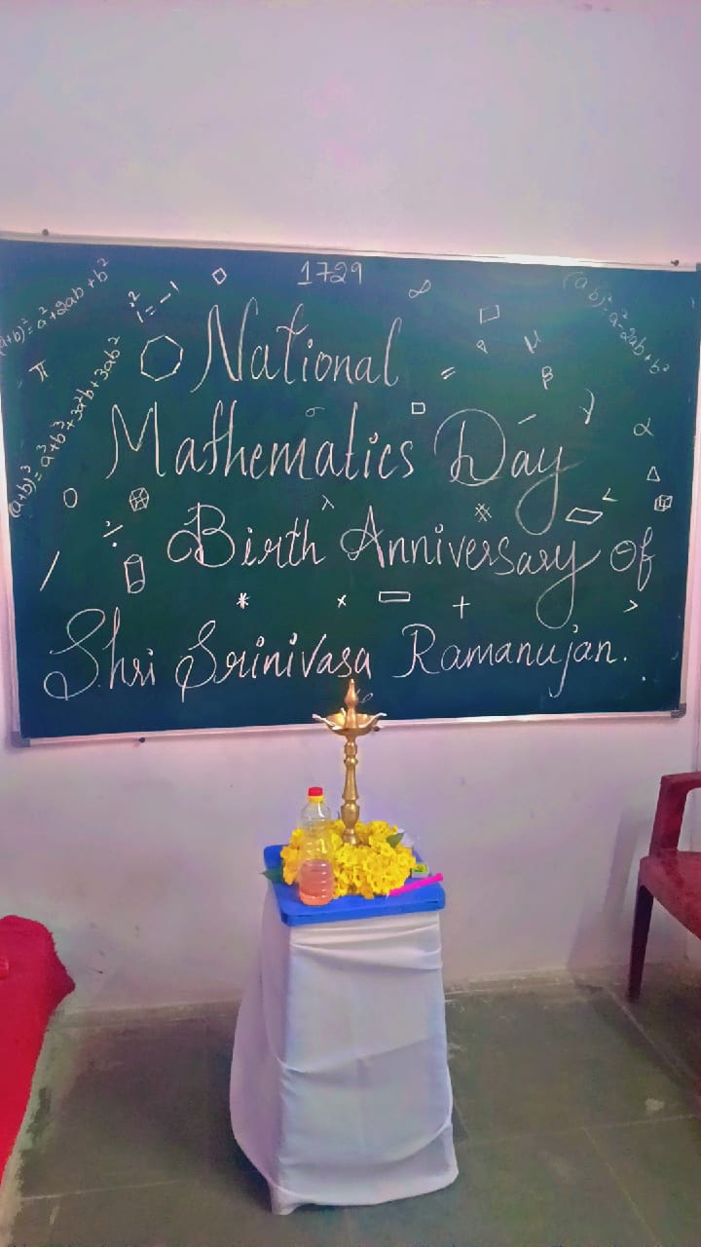
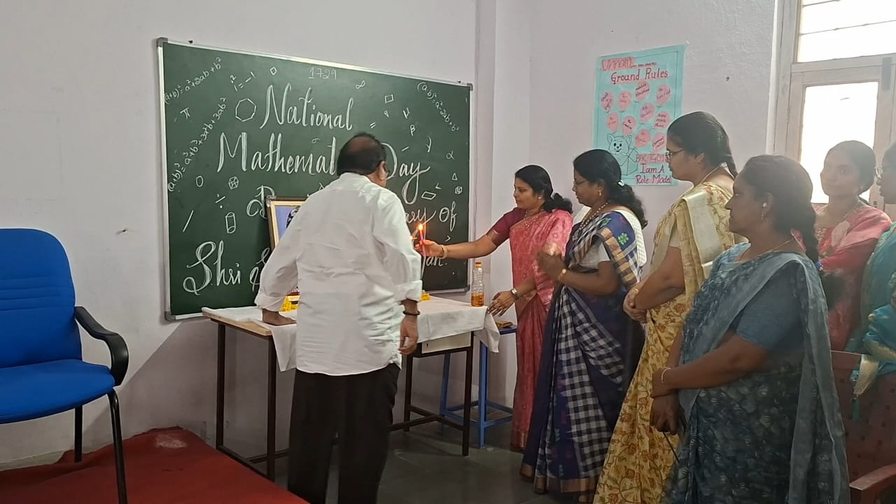

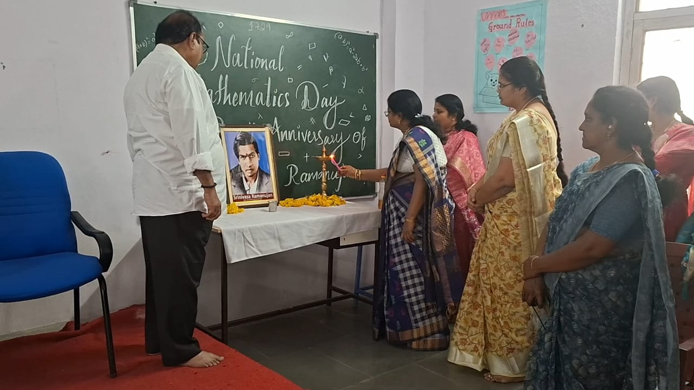

POWERPOINT PRESENTATION :
- Students prepared PowerPoint presentations on mathematical topics.
- Topics included famous mathematicians, applications of mathematics, and concepts.
- Presentations helped students improve communication and presentation skills.
- The best presentations were appreciated by the judges.

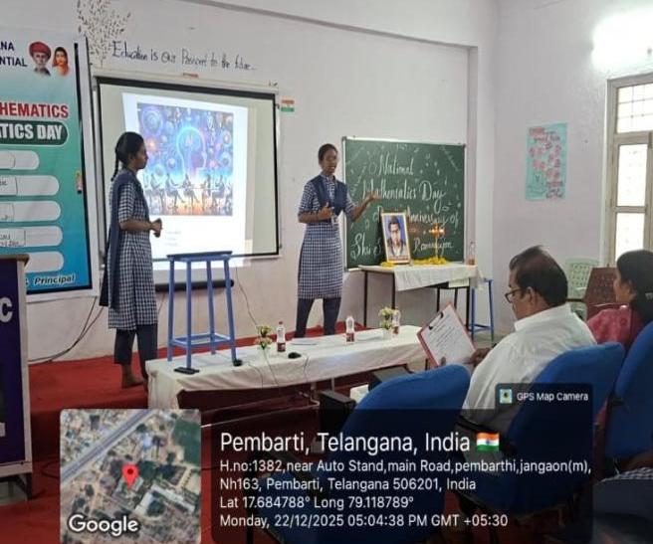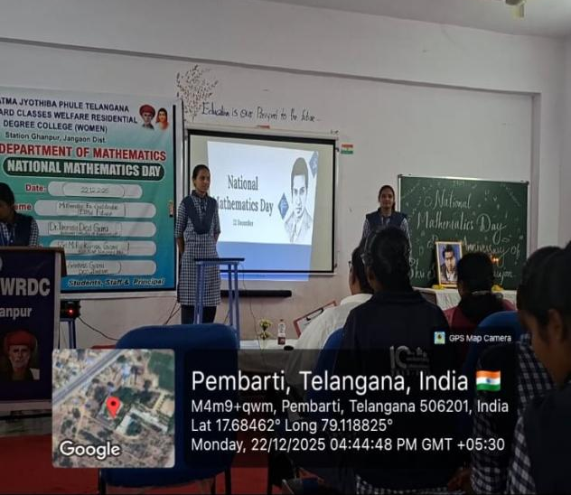
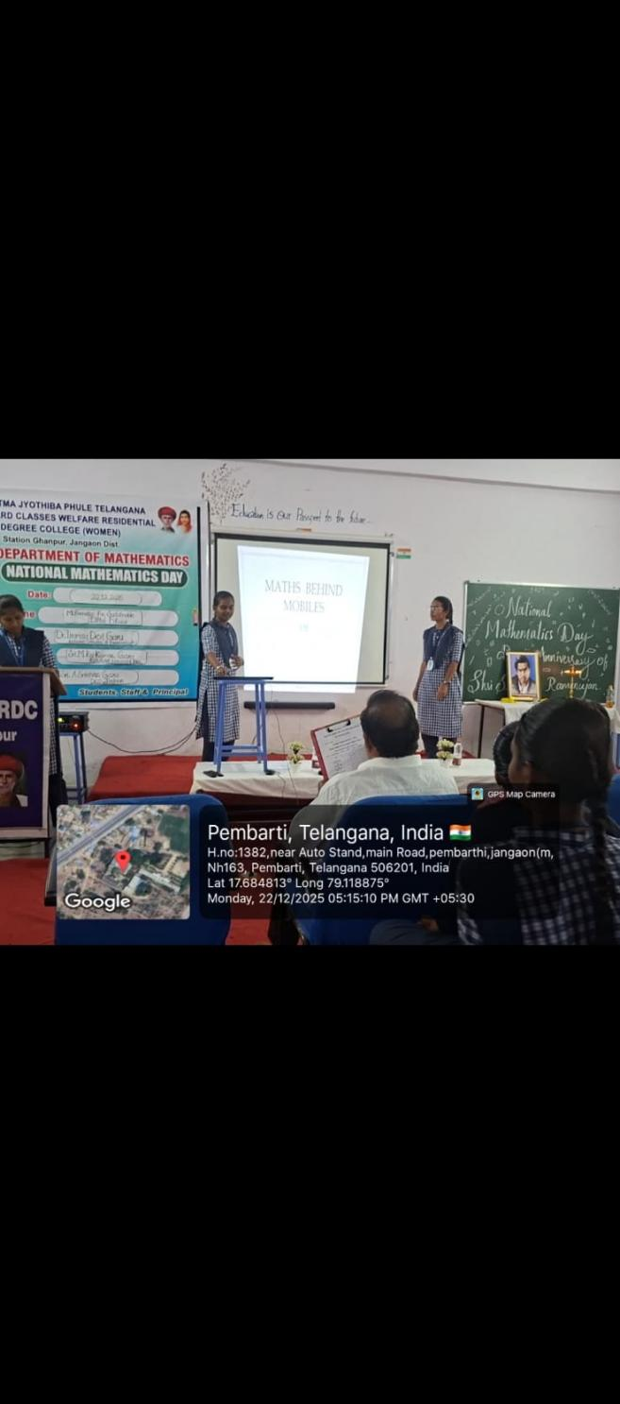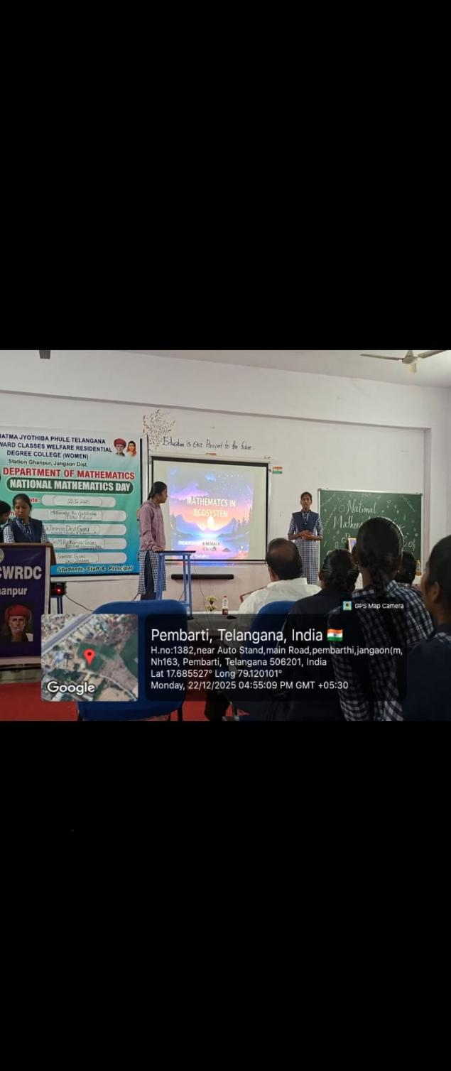
TOPICS ON WHICH POWERPOINT PRESENTATION HAS GIVEN :
- ROLE OF MATHEMATICS IN DIGITAL WORLD
- APPLICATIONS OF MATHEMATICS IN AGRICULTURE
- MATHEMATICS BEHIND ONLINE SHOPPING DISCOUNT ALGORITHM
- MATHEMATICS BEHIND MOBILE PHONE
- MATHEMATICS IN ECOSYSTEM
WINNERS OF PPT PRESENTATIONS : 1. V.SHIREESHA
2.R.VAISHNAVI
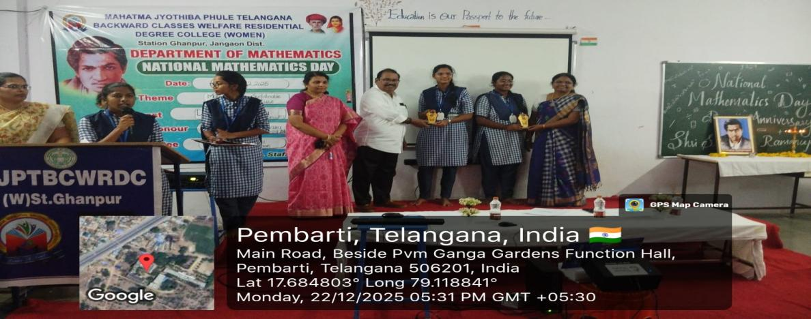

FELICITATION OF THE GUEST :
- At the end of the program, a felicitation ceremony was held in honour of the chief guest, Dr. Tirumala Devi Garu , Additional controller of examination ( ku.)
- The guest was respectfully honoured with a memento and shawl as a mark of gratitude.
- Dr. Tirumala Devi Garu addressed the gathering and motivated students to excel in mathematics.
- The felicitation ceremony marked the successful conclusion of National Mathematics Day celebrations.

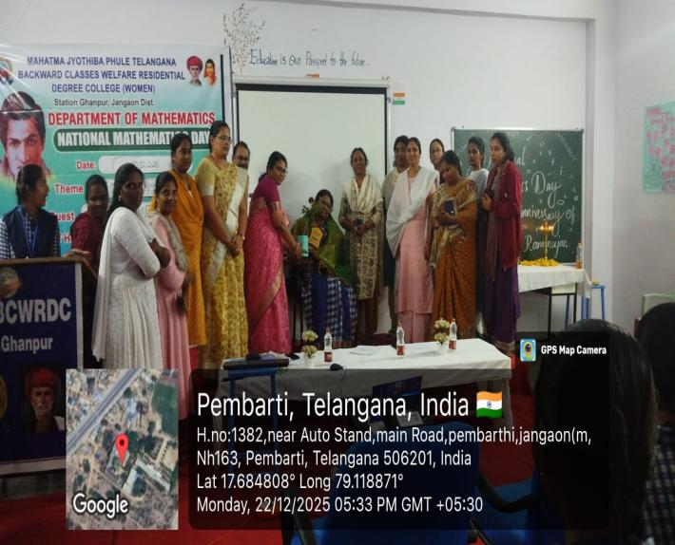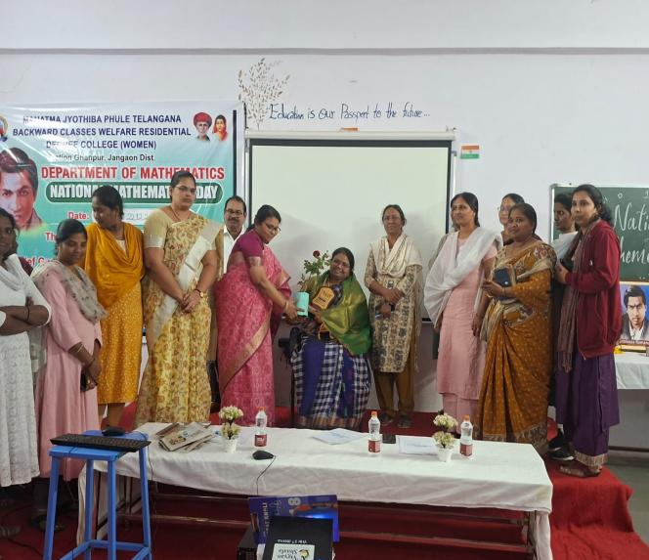

VOTE OF THANKS :
Conclusion of the day by expressing gratitude to our chief guest Dr. Tirumala Devi , and our Principal mam Dr. K.Bhagya laxmi mam and Principal sir Dr.NVN Chary sir all the faculty members and students. The programme has been successfully completed with lot of knowledge , fun and presentations.

PLACEMENTS AND HIGHER EDUCATION

- Higher studies M.Sc.(Applied math ,Pure math)
- Education and training.
- Banking and financial services.
- Civil services and public sectors.
- Information technology.
- Employment in teaching and public sector.
- Academia and research.

ALUMINI DETAILS
- Our first batch 2022-2025 has successfully completed their graduation in our institution and they are perusing for their higher studies.

FUTURE PLANES
- Math for All:
  - Promote inclusive education by supporting students who find math challenging through remedial classes and peer tutoring.
- Career Guidance:
- Math for All:
  - Promote inclusive education by supporting students who find math challenging through remedial classes and peer tutoring.
- Math for All:
  - Promote inclusive education by supporting students who find math challenging through remedial classes and peer tutoring.
- ath for All:
  - Promote inclusive education by supporting students who find math challenging through remedial classes and peer tutoring.

- Organize sessions on career opportunities in Data Science, Actuarial Science, Research, Teaching, etc.
- Collaboration with university and research institutions.
- To conduct out rich programme for school students and teachers to promote mathematics awareness and education.

BEST PRACTICES
- PG coaching class is been provided to the final year students.
- Skill-Based Learning:
  - Focus on problem-solving, logical reasoning, and real-life applications of mathematics.
- Math Clubs & Competitions:
- Establish or expand a Math Club to host quizzes, Olympiad training, and puzzle-solving sessions.
- Participate in national and international math contests
Research & Projects:
  - Encourage undergraduate research projects or capstone projects in pure and applied math.
  - Collaborate with other departments for interdisciplinary research.

